**Procedure:-**

**Step1:- go to sonar.io, login with your github account.**

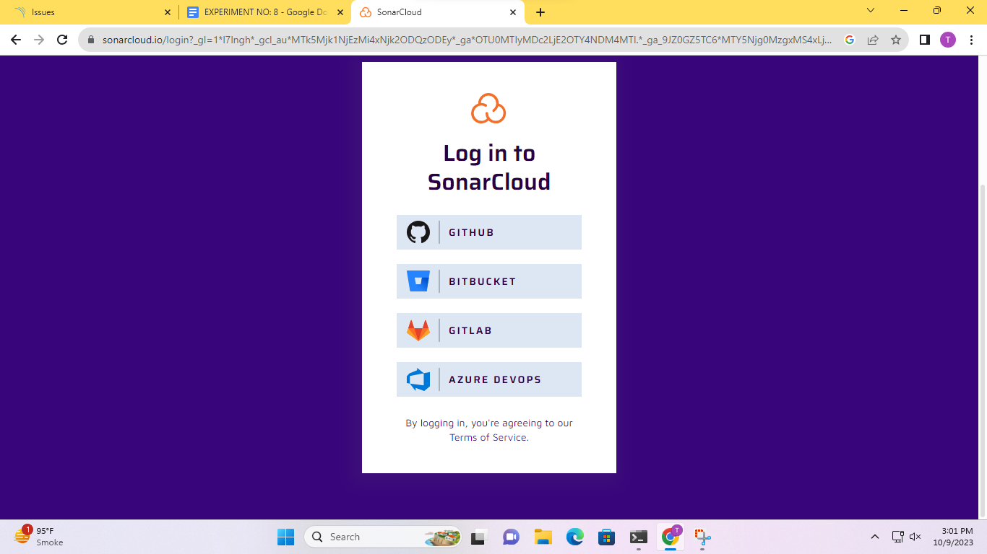

**Step2:- click on authorizedSonar cloud.**

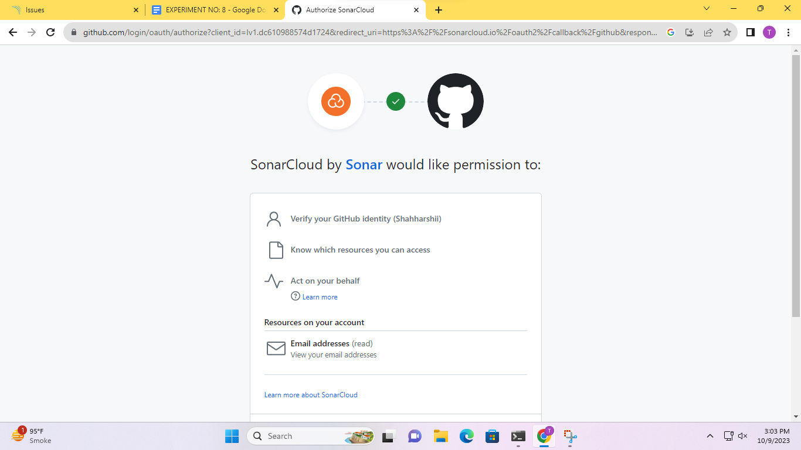

**Step3:- now, import organization from github.**

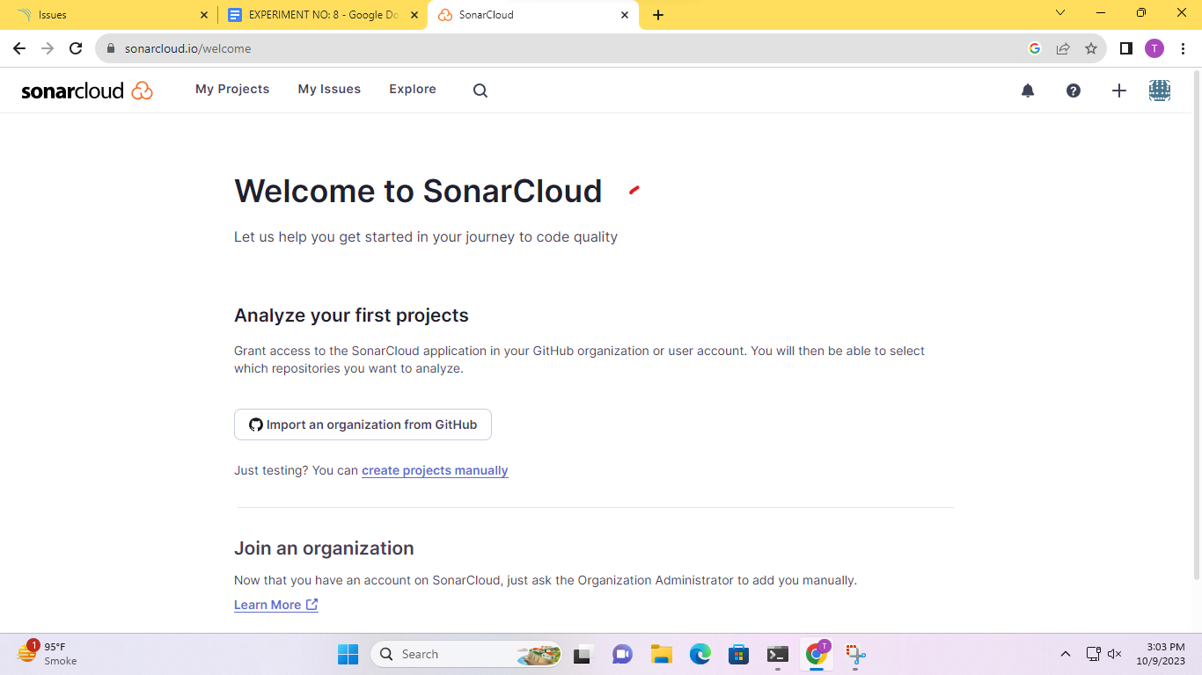

**Step4:- login to github and install.**

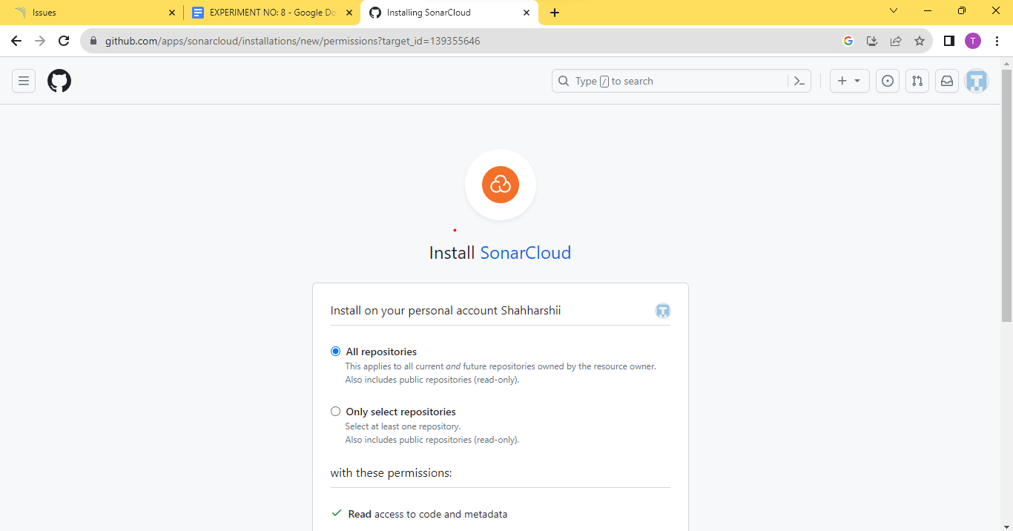

**Step5:- create an organization, enter your key.**

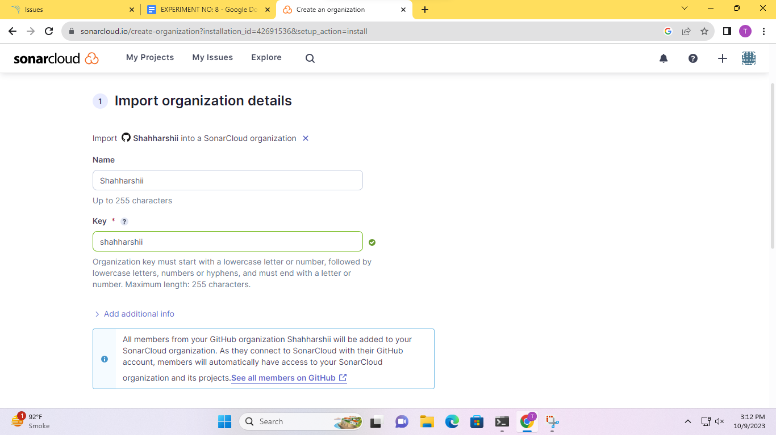

**Step6:- go to my Projects, then analyze new project.**

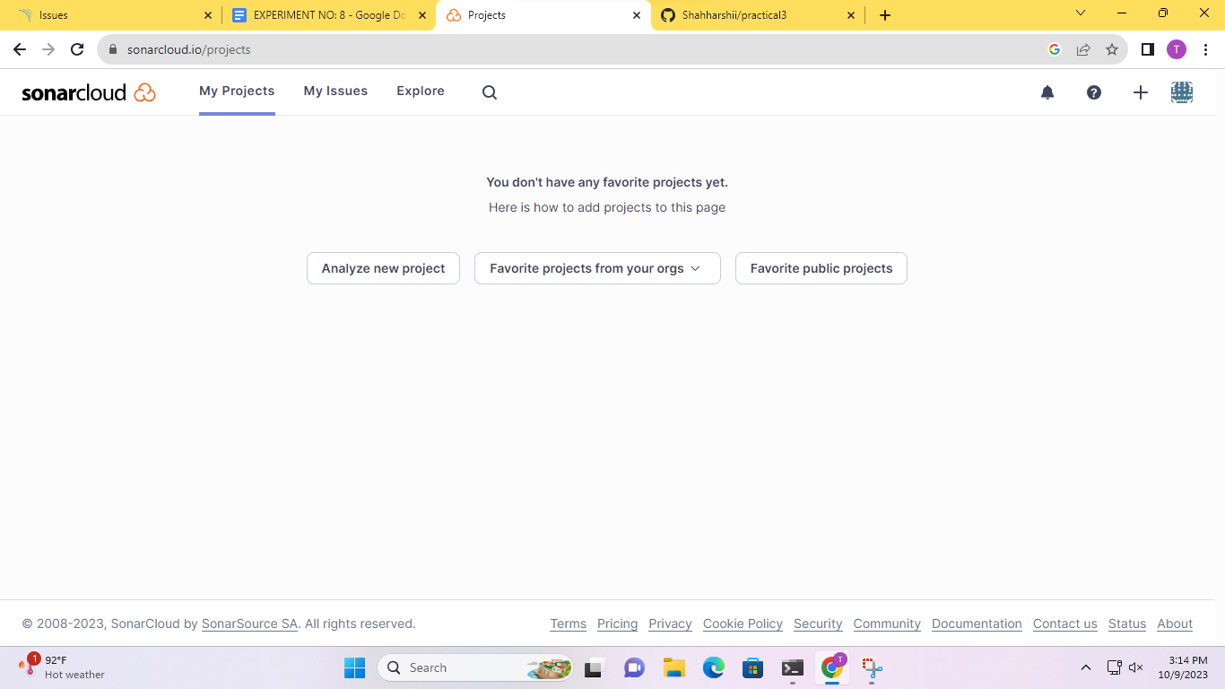

**Step7:- select all repositories.**

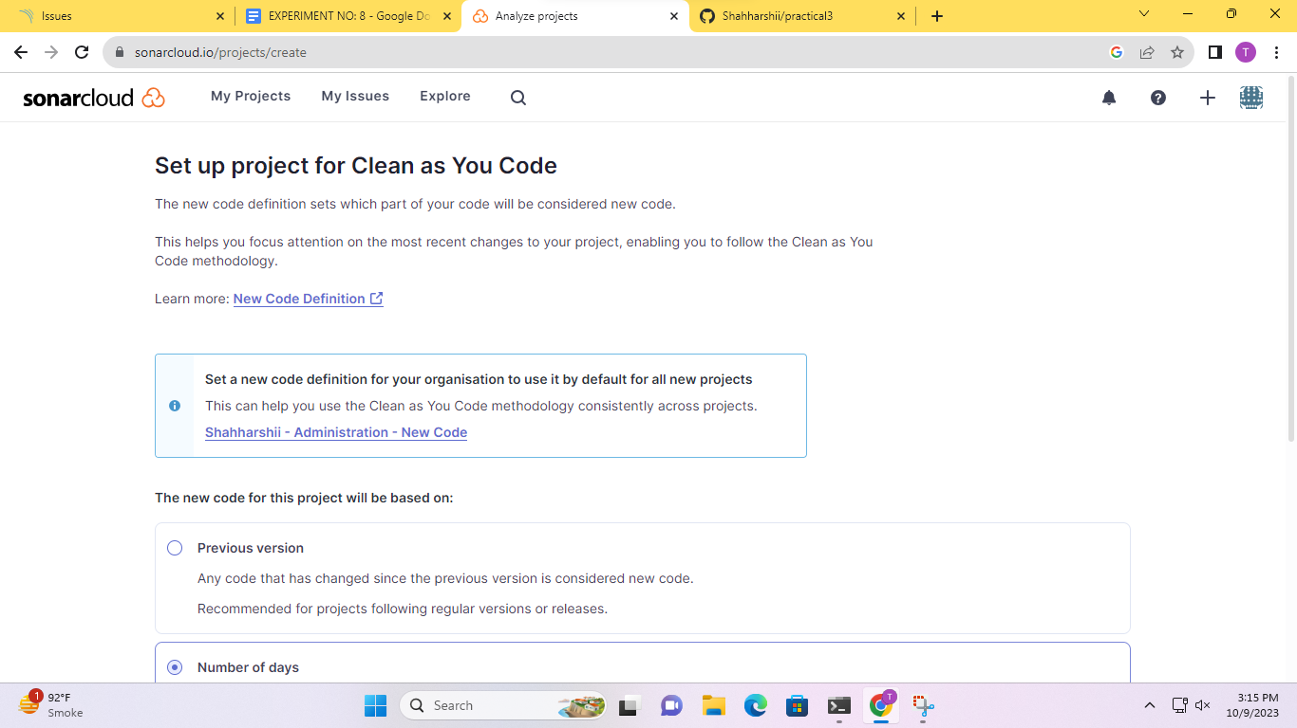

**Step8:- analysis of code.**

